附件一：作品信息表
无想而为
南京溧水无想山全域旅游公共艺术装置设计大赛
作品信息表
作品名称 | “种”
作品尺寸  （长*宽*高） | A:10m*10m*5m  B:50m*50m*10m  C:100m*100m*20m | 作品材质 | 高密度聚乙烯 ,光纤，
作者/创作团队  （团队请注明成员名字） | XTID  YAHU DING
联系电话 | 13240120828 | 电子邮箱 | 1250237410@qq.com
作品说明（400字左右）：
为避免对原有农业用地空间的过度侵占，设计以气球的概念性为引入点，设计未来感极强的充气式漂浮雕塑来做地标性景观,极具视觉冲击力的异形种子的下坠感给人提供冥想的媒介，同时也是对当今转基因种子入侵的一种回应和对伪科学一种讽刺。雕塑顶部采用超薄光伏板为发电材料,底部通过光纤与地面相连,雕塑高度随pm2.5浓度的递增依次递减,随着空气质量的变差,光纤从蓝色逐渐变为红色进行预警。在雾霾来袭时，通过巨型雕塑下坠带来的压迫感来警示人们善待自然，保护环境。我们希望这不只是一次时空间的对话，更是赖以生存的地球给人类的一次警告。
制作时间表和预算
制作时间：30天。
预算：雕塑分ABC大小三种型号，单组组合约20万,整体组合约120万。（可依据实际资金和效果自由组合搭配）。
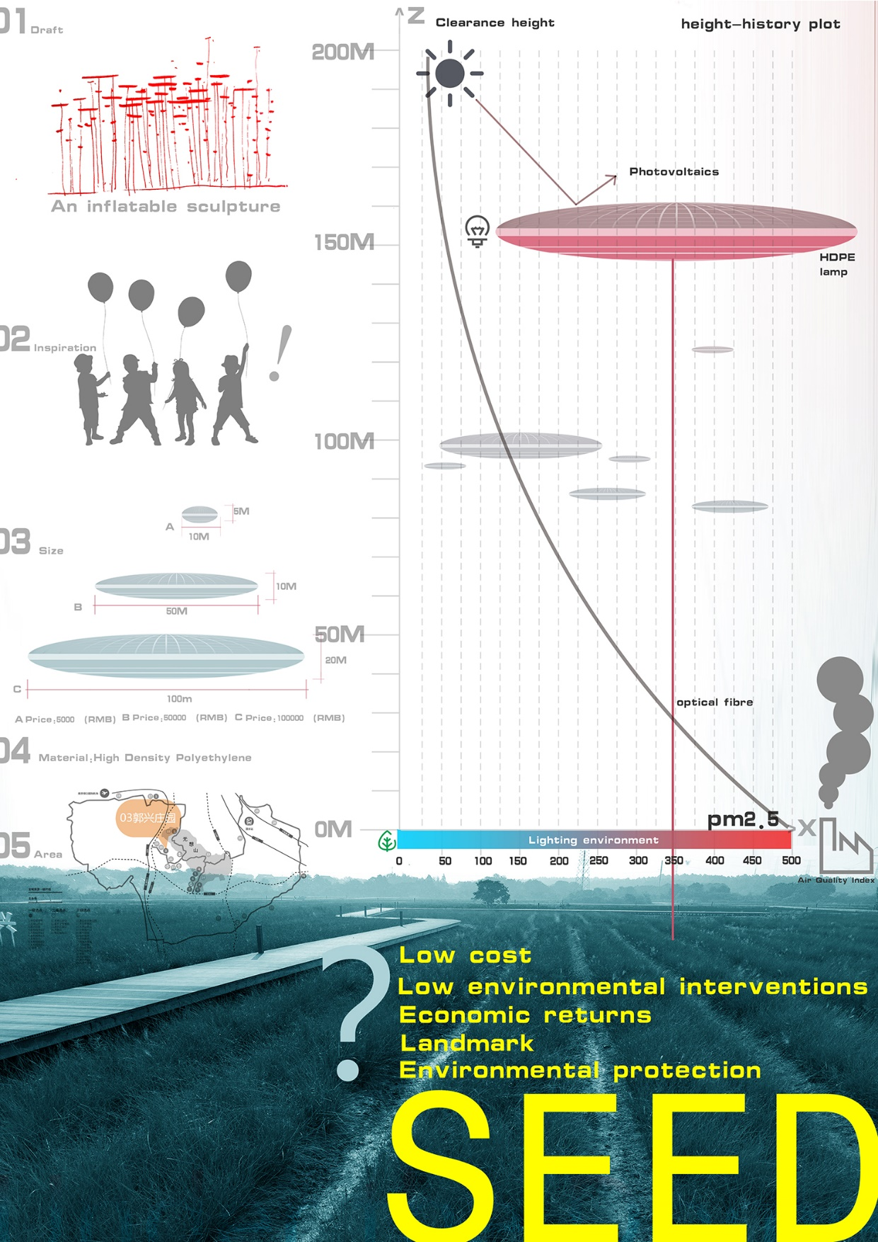

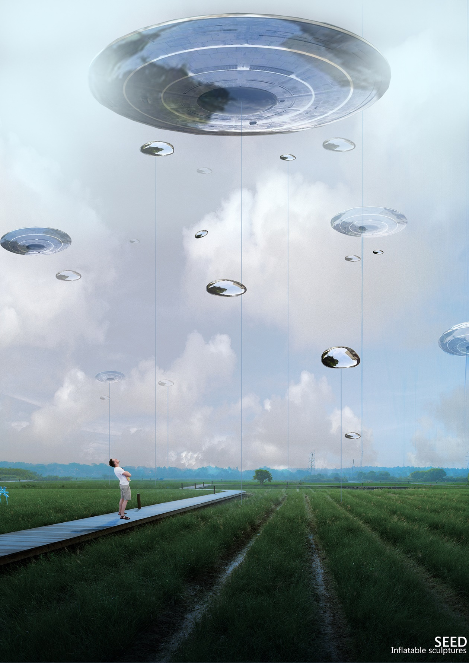

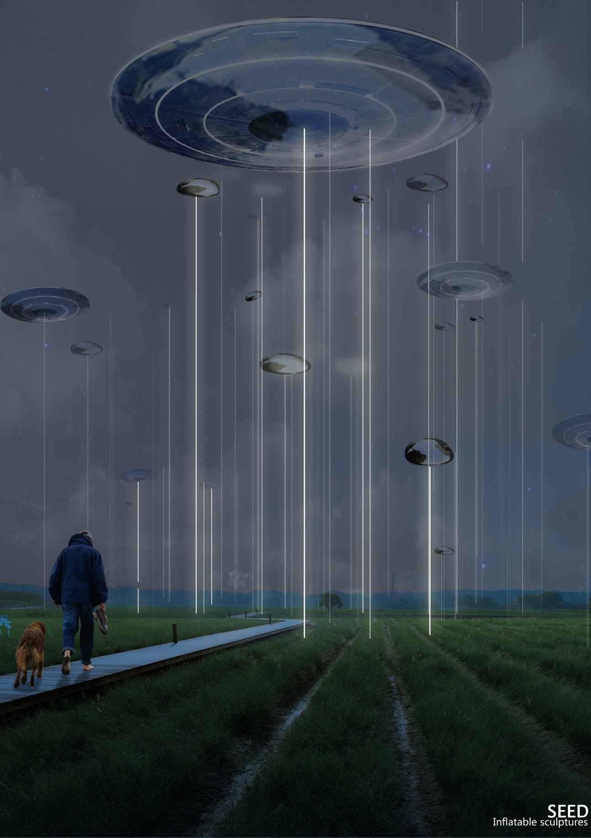

Application Form
Nonintervention
WUXIANG mountain tourism public earth art competition in LISHUI, NANJING city
Application Form
Name of the work | seed
Size  （length*width*height） | A:10m*10m*5m  B:50m*50m*10m  C:100m*100m*20m | material | Hdpe,optical fibre
Name of the artist  (if group, name of all the group members) | XTID  DING YAHU
Mobile number | 13240120828 | Email address | 1250237410@qq.COM
In order to avoid over occupying the original agricultural land space, using balloon as the design concept.The design uses a disc-shaped inflatable floating sculpture with a sci-fi sense as a landscape landmark. The falling alien seeds have visual impact and provide a medium for meditation. At the same time, it is also a response to the invasion of today's genetically modified seeds, satirize pseudoscience.
The ultra thin photovoltaic panels are used as power generation materials at the top of the sculpture, the bottom is connected to the ground by optical fiber. The height of sculpture floating decreases with PM2.5 concentration increasing. As the air quality decreases, the fiber gradually changes from blue to red, for early warning. When haze strikes, through the pressing feeling brought by the falling giant sculpture, it warns human to be kind to nature and protect the environment. We hope this is not only a time and space dialogue but also a warning from the unique earth to human.
Production timetable and budget
Production time: 30 days.
Budget: The sculpture is divided into three sizes A, B and C. The single group combination is about 200 thousand. The overall combination is about 1 million 200 thousand. (They can freely mix and match, according to actual funds and effects)

